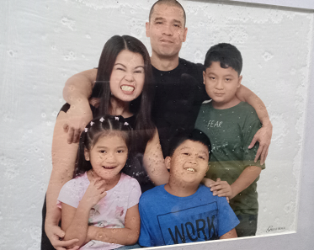

This is my family. We are alike in some ways but we also differ in a lot of ways. All five of us love to eat. I and my siblings love to play online games, my mom loves to read while my dad loves outdoor activities such as biking. While my mom loves plants and gardening, the rest of us love pets such as dogs, cats, rabbits, birds and chickens.